|  |
| --- |
|  |
| Capstone Project Document |

**DANDELION**

Report #6 – User Manual

|  |  |  |
| --- | --- | --- |
| **Dandelion** | | |
| **Group Members** | Vũ Công Chính | SE02585 |
| Lưu Ngọc Mạnh | SE02619 |
| Nguyễn Minh Huy | SE02723 |
| Dương Đức Anh | SE02700 |
| Vũ Ngọc Trung | SE02967 |
| Cao Thị Phương Mai | SE02908 |
| **Supervisor** | Mr. Nguyễn Văn Sang | |
| **Project code** | DDL | |

**- Hanoi, 12/2015 -**

# SIGNATURE PAGE

AUTHOR: Vũ Công Chính 07/12/2015

Team member

REVIEWERS: Lưu Ngọc Mạnh 12/12/2015

Project manager

APPROVAL: Nguyễn Văn Sang --/--/--15

Supervisor

Record of change

*A - Added M - Modified D – Deleted

|  |  |  |  |  |  |
| --- | --- | --- | --- | --- | --- |
| Effective Date | Changed Item | A,M,D | Change Description | Reason for Change | Rev. Number |
| 07/Dec/2015 | User installation | A | Add new |  | 1.0 |
| 10/Dec/2015 | User guide | A | Add new |  | 1.0 |
|  |  |  |  |  |  |
|  |  |  |  |  |  |
|  |  |  |  |  |  |
|  |  |  |  |  |  |
|  |  |  |  |  |  |
|  |  |  |  |  |  |
|  |  |  |  |  |  |
|  |  |  |  |  |  |
|  |  |  |  |  |  |
|  |  |  |  |  |  |
|  |  |  |  |  |  |
|  |  |  |  |  |  |
|  |  |  |  |  |  |
|  |  |  |  |  |  |
|  |  |  |  |  |  |

Table of Contents

SIGNATURE PAGE 1

Introduction 3

1.1 Purpose 3

1.2 Definitions, Acronyms and Abbreviations 3

1.3 Overview 3

2 Screen flow 4

2.1 Register 4

2.2 Login 5

2.3 Search project 6

2.4 Discover 7

2.5 Create project 9

2.6 Edit project 11

2.7 Statistic 11

2.8 Project detail 11

2.9 Back project 11

2.10 Message 11

2.11 Project management 11

2.12 Account management 11

2.13 ADMIN 11

# Introduction

## Purpose

This document contains guide-lines step by step to use FAP website, and set up its own database.

## Environment

Following are the software required to start the FAP system:

* Operating System: Windows 7, Windows 8
* Browsers: Firefox 40, Chrome 44 or higher.
* Database: Neo4j 2.2.3 or higher
* .NET Framework 4.5

## Application Installations

### Setup environments

#### Setup abc1

#### Setup abc2

### Installation Web Application

# USER GUIDELINES

## Register

This is the first page which user will see. From this page the user can go to every page they want.

To register account on website, the users do the steps below:

Step 1: Open browser and enter to the address bar: <http://dandelionvn.com/>. Homepage is displayed.

Step 2: Click on Đăng ký button in header. Users will go to Register page.

Step 3: Enter information and click on Đăng ký button or User can register by choose Login with Facebook.

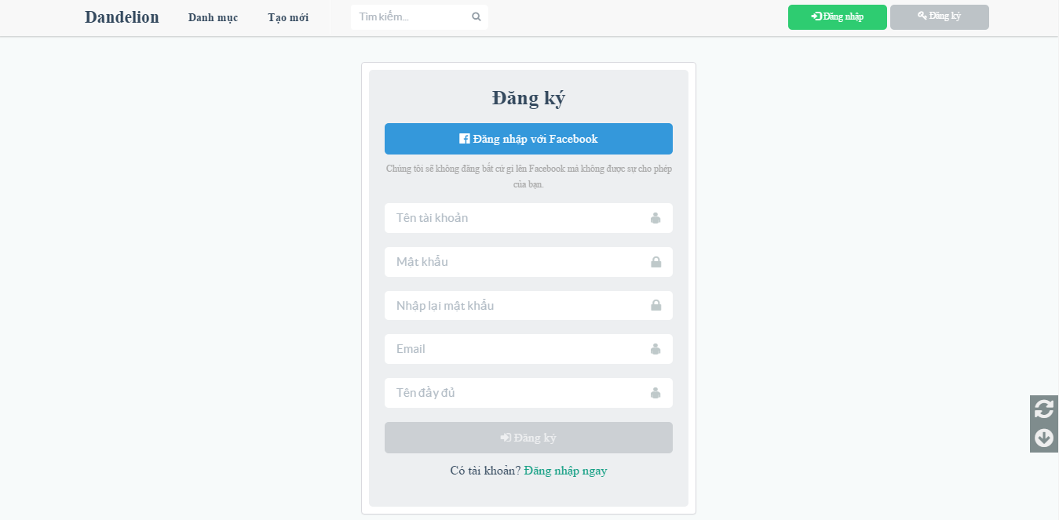

1. R**egister screen**

## Login

To login account on website, the users do the steps below:

Step 1: Open browser and enter to the address bar: <http://dandelionvn.com/>. Homepage is displayed.

Step 2: Click on Đăng nhập button in header. User will go to Login page.

Step 3: User can choose Login with Facebook.

Step 3: User can choose Login with DDL’account:

Step 3.1: User enter username and password

Step 3.2: Click on Login button

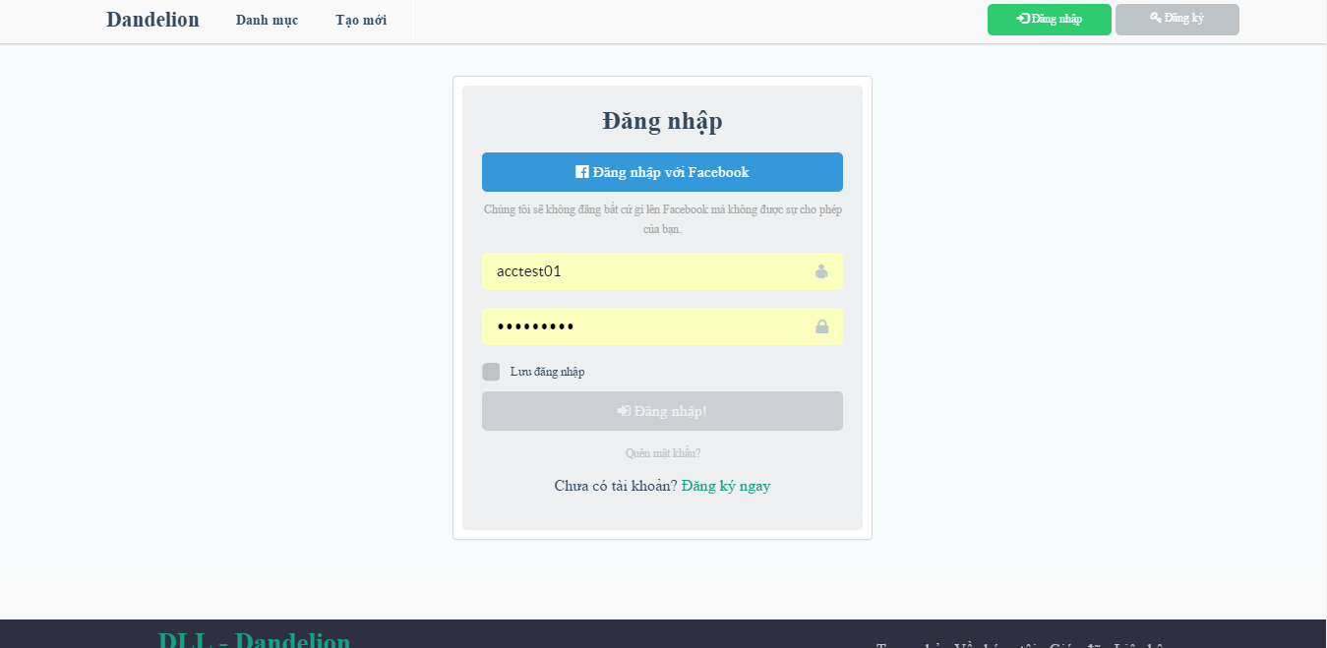

1. Login **page**

## Search project

To use search function on website, the users do the steps below:

Step 1: In Home page, enter project to search in header.

Step 2: Click on search icon or press enter.

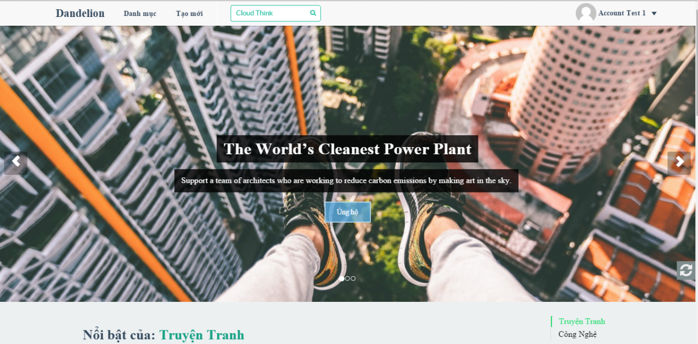

1. Search project

Step3: Search result page is displayed.

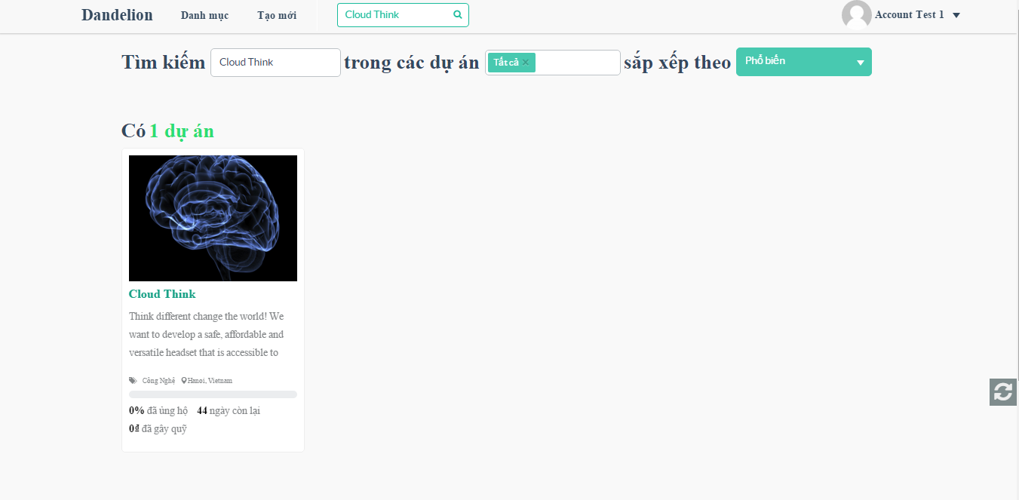

1. Search project result

## Discover

In this page, user can view projects, view status of project and filter project by level, status… Go to Discover page, the user do the steps below:

Step 1: Go to Homepage.

Step 2: Click on Discover (“Khám phá”) button in header

Step 3: Discover page is displayed and allow user can view and filter project.

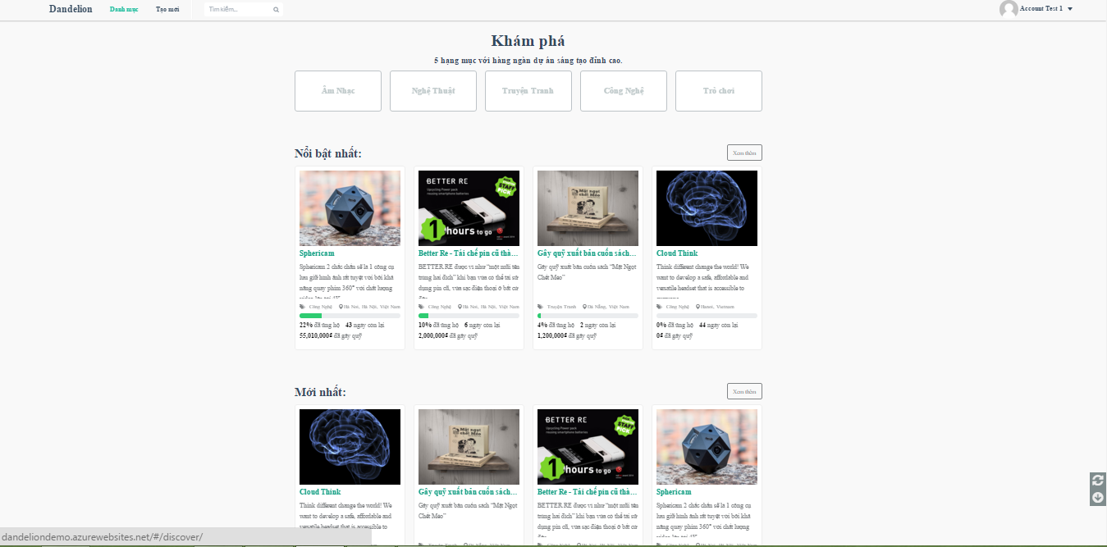

1. Discover

## Create project

In this page, user view projects, view status of project and filter project by level, status… Go to Discover page, the user do the steps below:

Step 1: Go to Homepage.

Step 2: Click on Create (“Tạo mới”) button in header. System will go to Create project page.

Step 3: User enter information

Step 4: Click on Start (“Bắt đầu”) button.

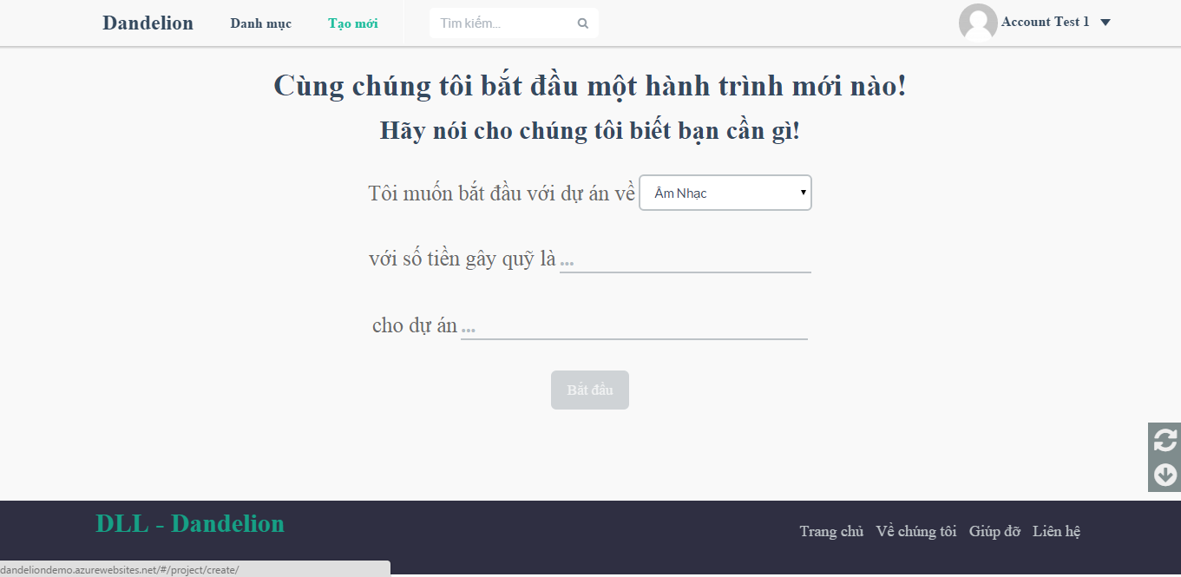

1. Create project screen

Step 5: Confirm form is display some of information of yours project . Click Yes to create project, click No to cancel.

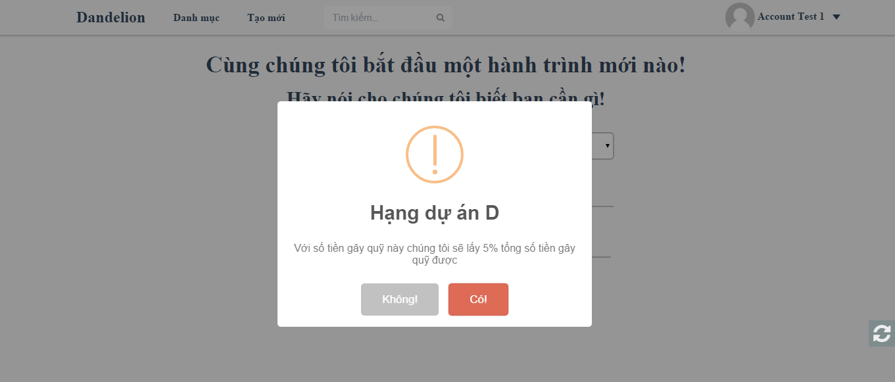

1. Popup create project screen

## Edit project

When project is created user can edit project by the way go to edit project page.

Step 1: Go to edit project page.

Step 2: In this page, have tabs to user enter information

Step 3: Click submit (“Gửi dự án”) button project to admin review and accept project.

### Basic tab

User choose image, enter name, short description, category, position, goal, time. Them save information.

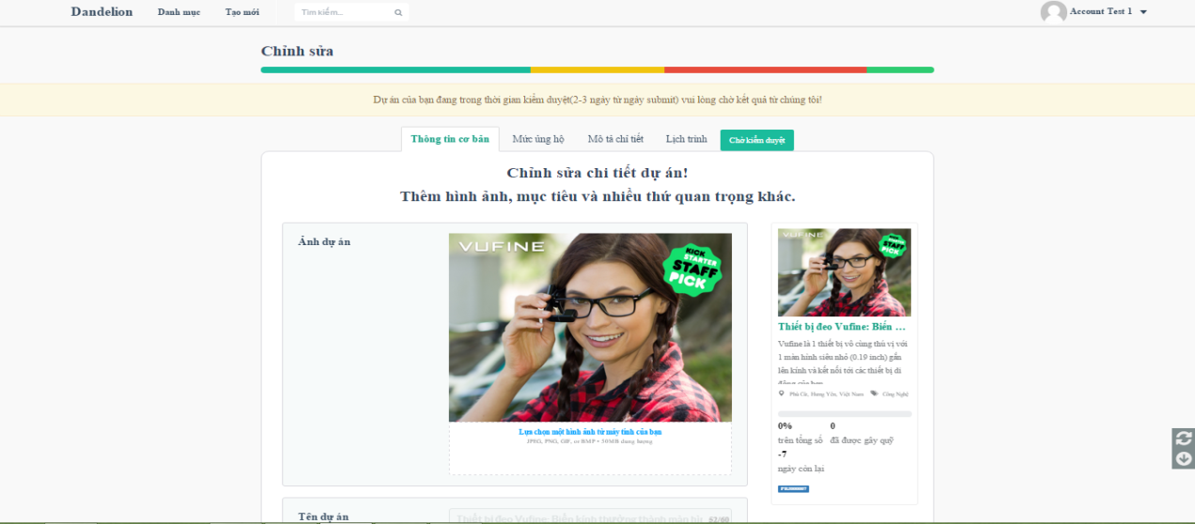

1. Basic tab screen

### Reward tab

User create reward to give people donate project. At a reward user can edit, hide reward.

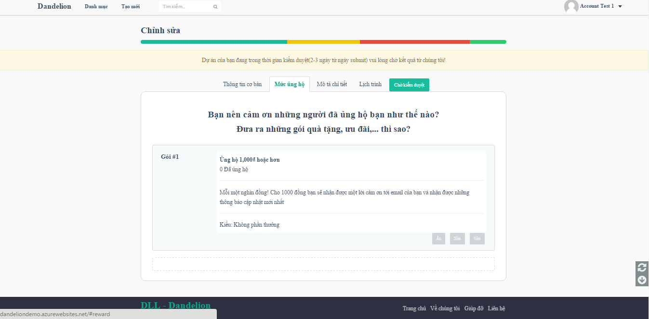

1. Reward tab screen

To create reward user do the step below:

Step 1: Click on Add new reward.

Step 2: Enter information reward

Step 3: Click on Create button

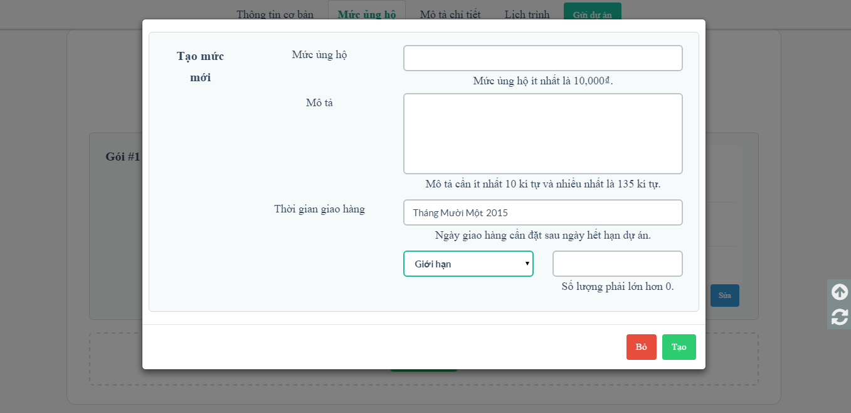

1. Reward tab screen

### Story tab

In this tab, user fills information details about project.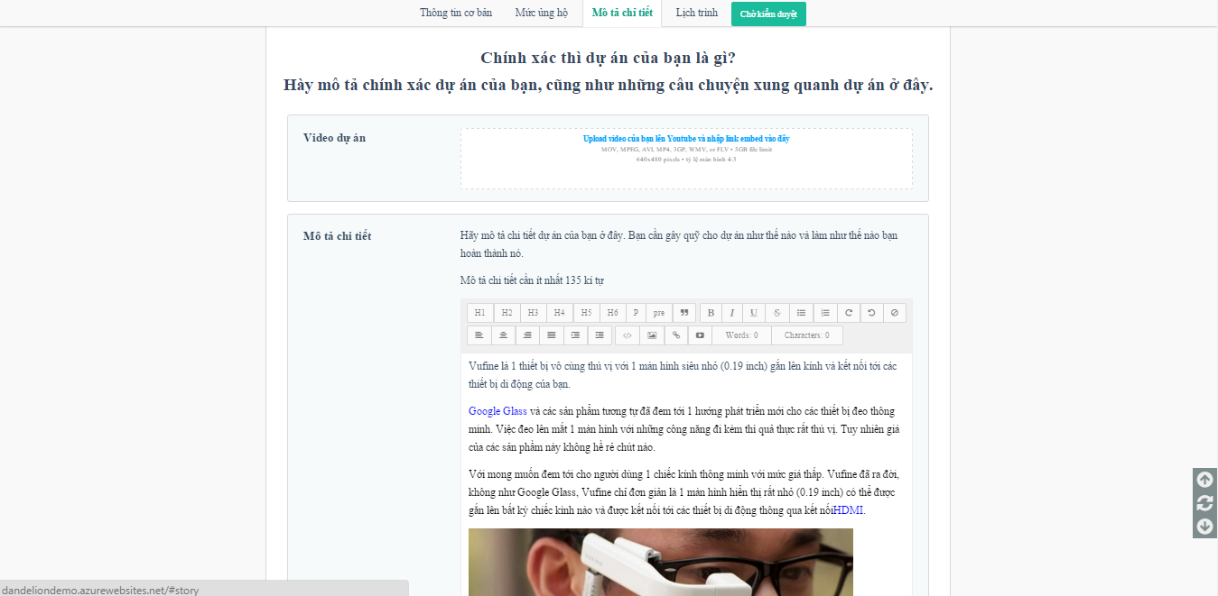

1. Story tab screen

### Update tab

User create update version to people can follow status project.

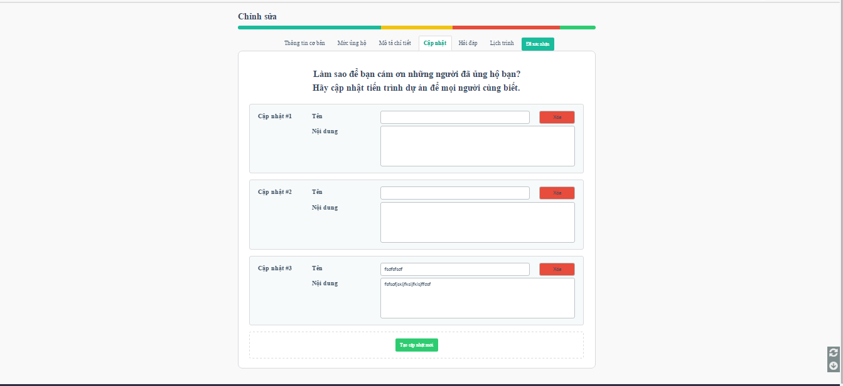

1. Update tab screen

To create update user do the step below:

Step 1: Click on Add new update.

Step 2: Enter information update

Step 3: Click on Create button

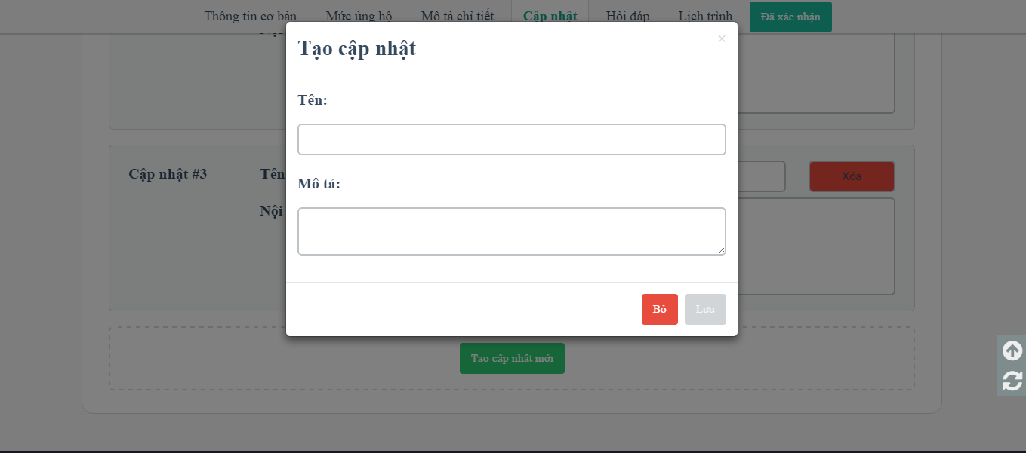

1. Create new update

### Question and Answer tab

User create Q&A to answer the question about project.

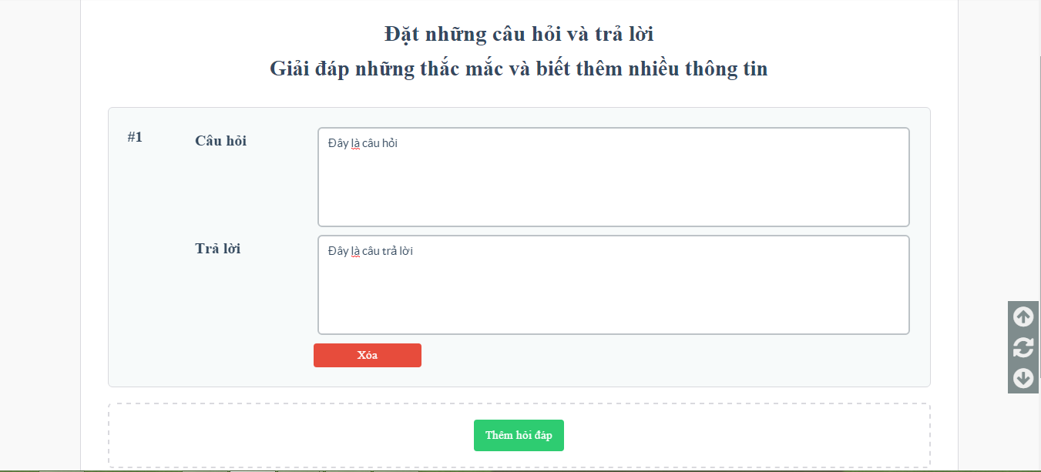

1. Q&A tab screen

To create update user do the step below:

Step 1: Click on Add new Q&A.

Step 2: Enter question and answer.

Step 3: Click on Create button

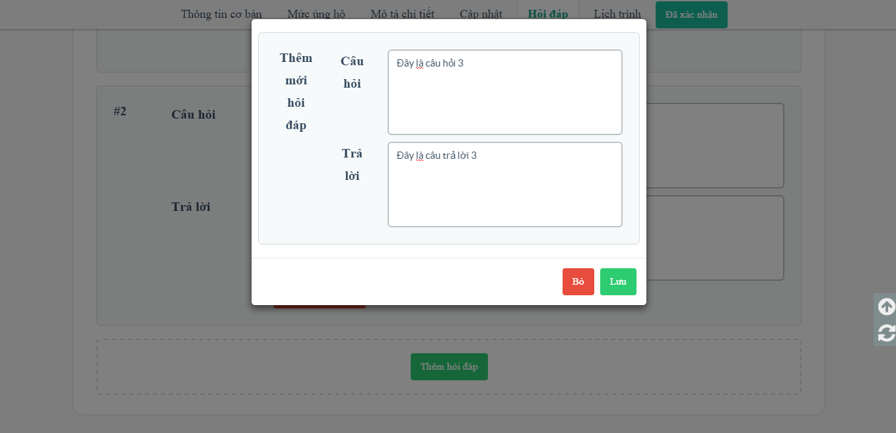

1. Create new Q&A

## Project detail

In this page user can view details project. And user also can use share, follow, back, comment, report, sent question to creator.

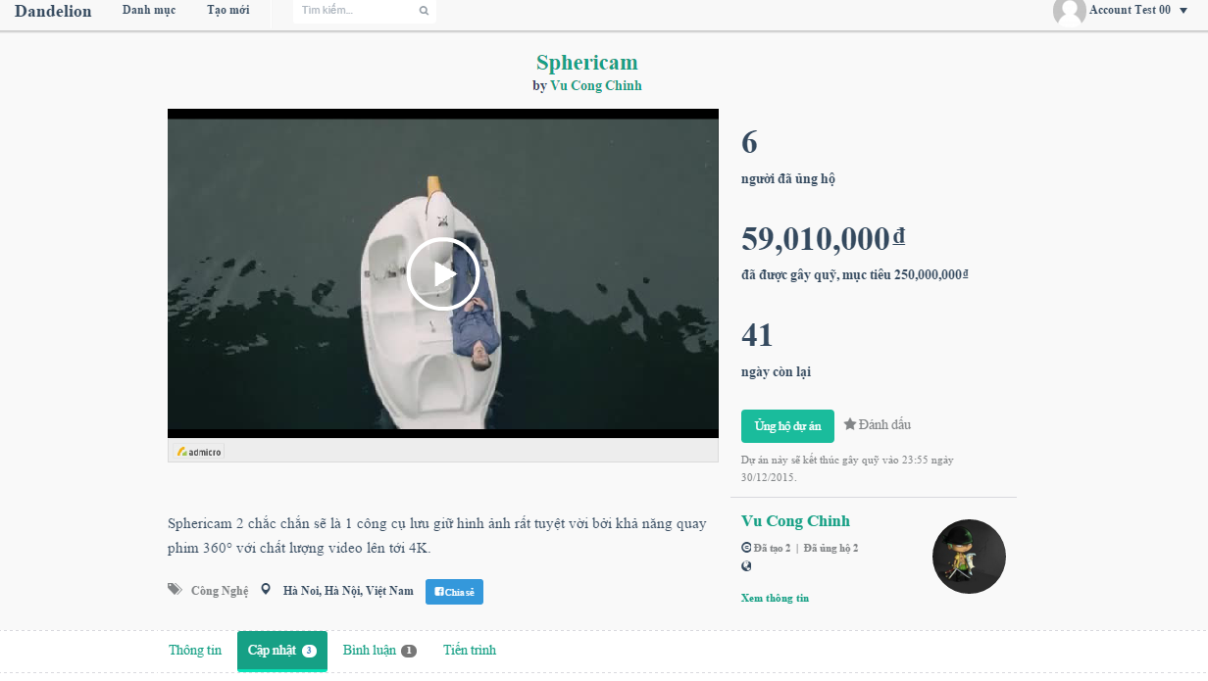

1. Project detail screen

### Share project

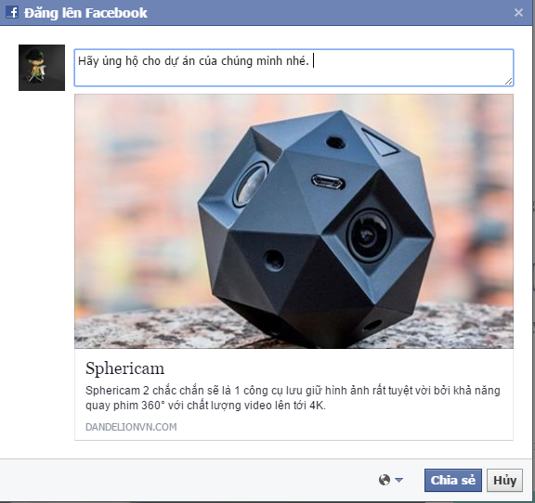

1. Share project

### Remind, follow project

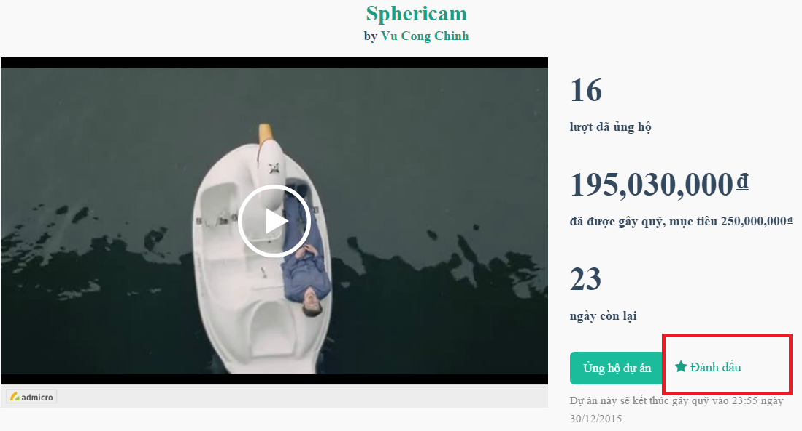

1. Follow/remind project

### Sent question about project

To sent question about project user do the step below:

Step 1: Go to project detail of a project

Step 2: Go to Thông tin tab and click on Gửi câu hỏi button

Step 3: Enter question and click on Gửi câu hỏi.

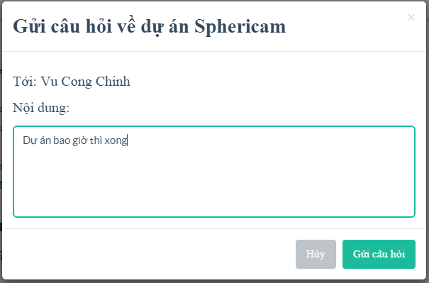

1. Sent question

### Report project

To sent report about project user do the step below:

Step 1: Go to project detail of a project

Step 2: Go to Thông tin tab and click on Báo cáo sai phạm button

Step 3: Enter content and click on Gửi báo cáo.

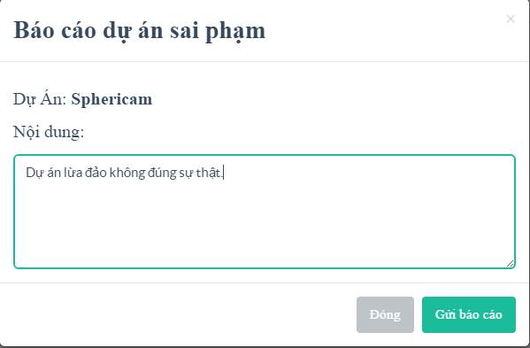

1. Sent report

### Comment tab

User can comment all of things relate about project

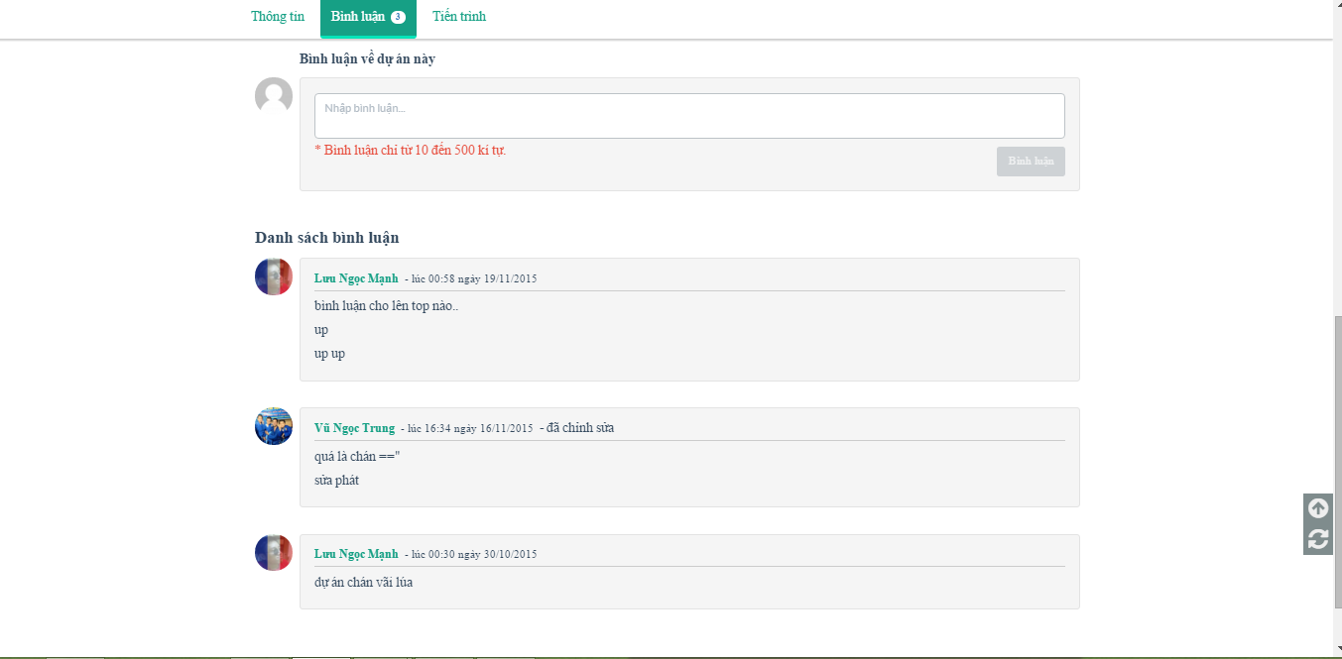

1. Comment tab screen

## Back project

This is the most importance feature. To use this fearture user do the steps below:

Step 1: From project details page, click back this project button (“Ủng hộ dự án”). System go to back project page.

Step 2: Choose a reward, then fill pledge and click continue button. System go to payment project.

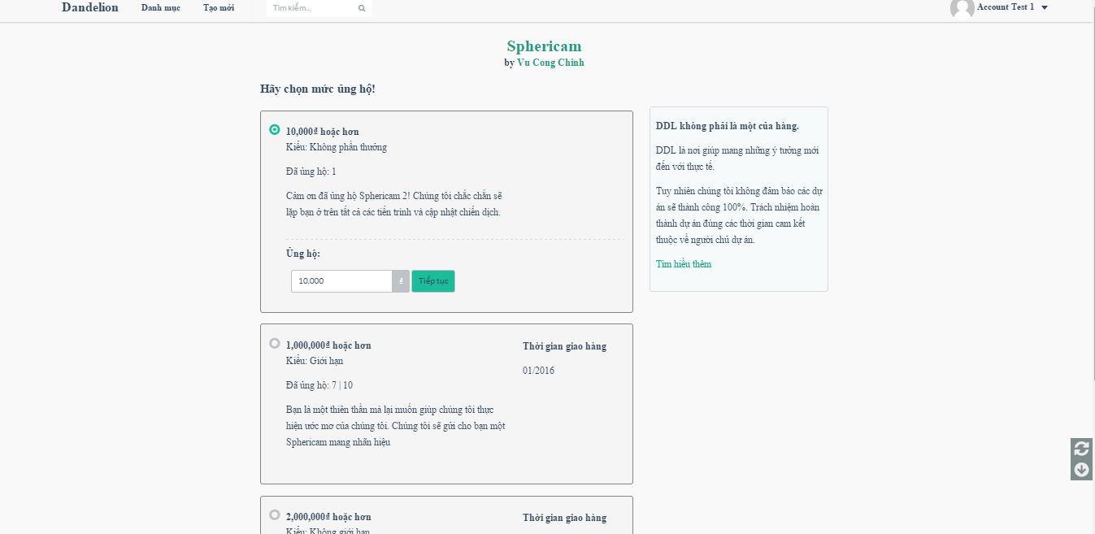

1. Back project screen

Step 3: Enter information and click on Ủng hộ button. System go to the Bao Kim and backer complete some of step in Baokim to back success project.

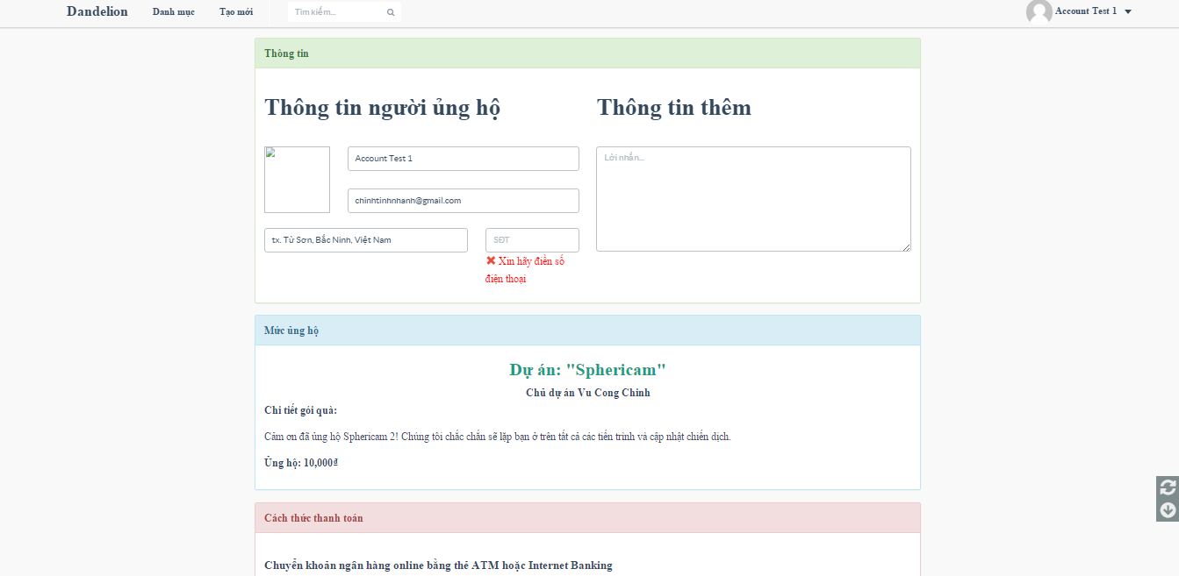

1. Payment project screen

## Message

In this page user can view messages to create new message, delete message, view message conversation.

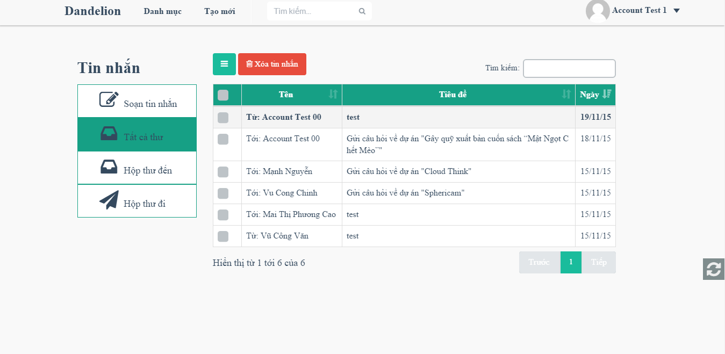

1. Message screen

### Sent message

To sent message user do the steps below:

Step 1: Click on avatar in header, then click on Message “Tin nhắn” button. System go to message page.

Step 2: Click on “Soạn tin nhắn” button.

Step 3: Enter information and click sent button.

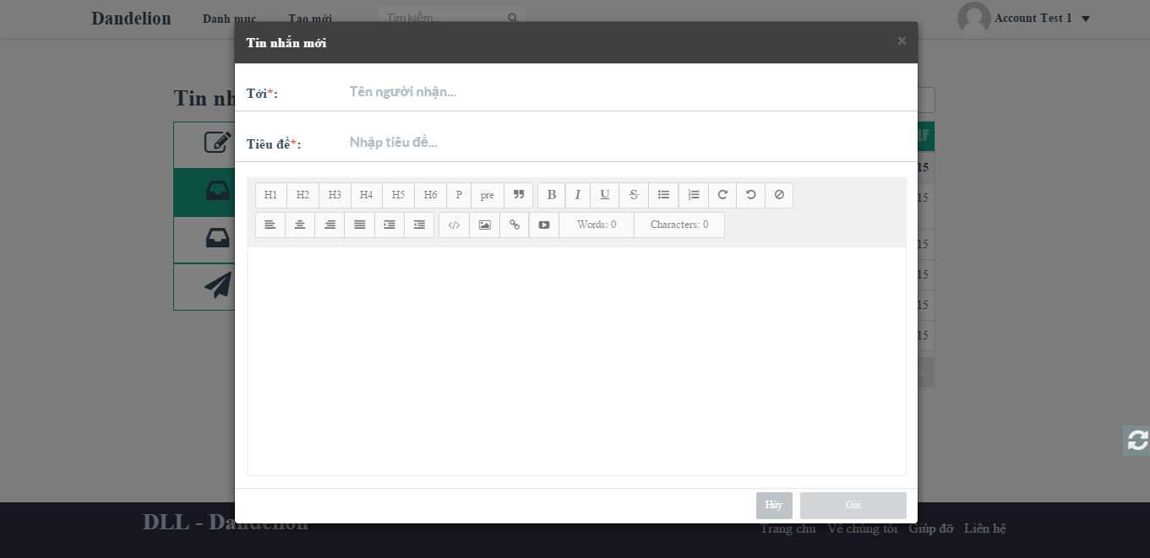

1. Sent message

### Delete message

To delete message user do the steps below:

Step 1: Click on avatar in header, then click on Message “Tin nhắn” button. System go to message page.

Step 2: Select message want to delete.

Step 3: Click delete button, confirm delete

Step 4: Click Yes to delete messages, No to cancel.

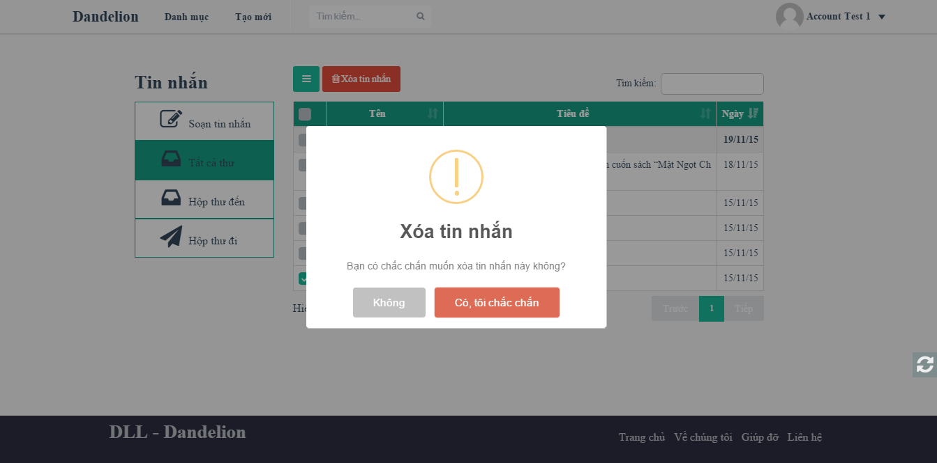

1. Delete message screen

### Message view

In this page, user can sent and receive message create a conversation. To view conversation user do the steps below:

Step 1: Click on avatar in header, then click on Message “Tin nhắn” button. System go to message page.

Step 2: Click on a message to view conversation.

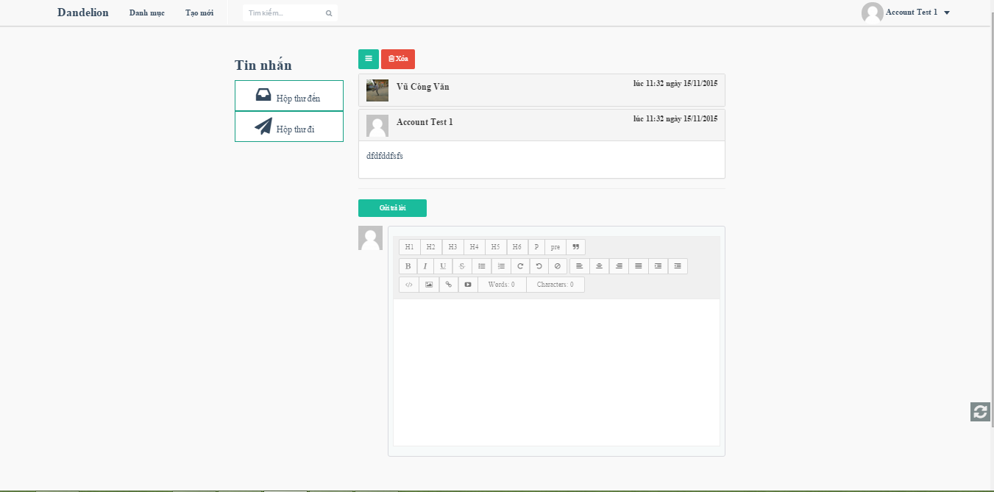

1. Message view screen

## Project management

In this page help user manage project created, backed, reminded.

### Created project

To view project created user do the steps below:

Step 1: Click on avatar in header, then click on Created Project “Dự án đã tạo” button. System go to created project page.

Step 2: User can delete draft project.

Step 2: Or User can edit draft project, running project.

Step 2: Or User can view list backer of running project.

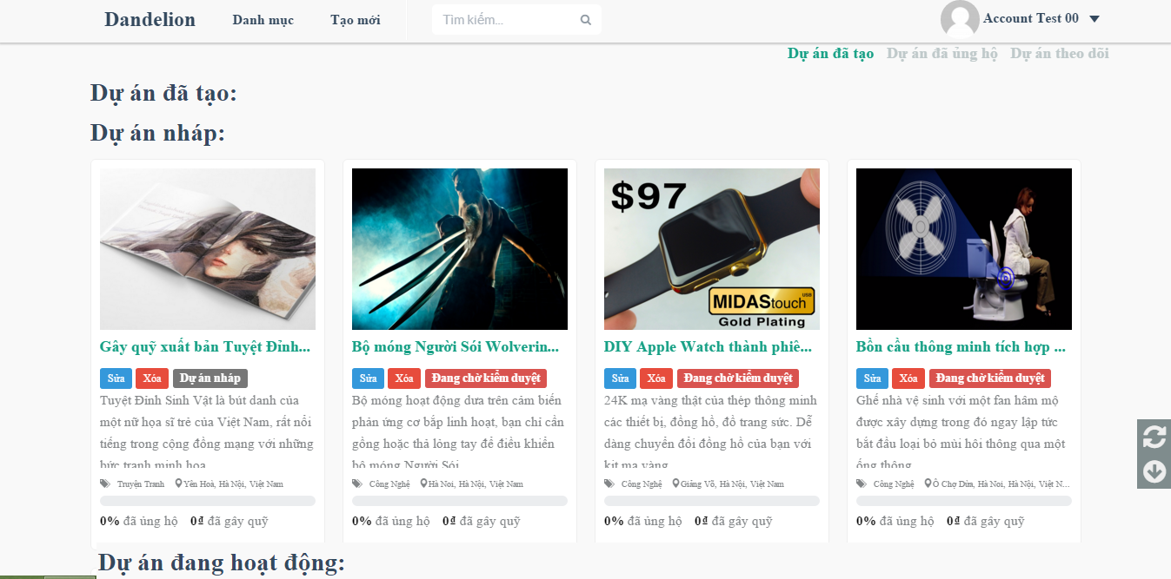

1. Created project screen

### List backer project

To view list backer user do the steps below:

Step 1: Click on avatar in header, then click on Created Project “Dự án đã tạo” button. System will go to created project page.

Step 2: Click on view list backer of project. System will go to list backer page

Step 3: Choose a backer and click view backing details.

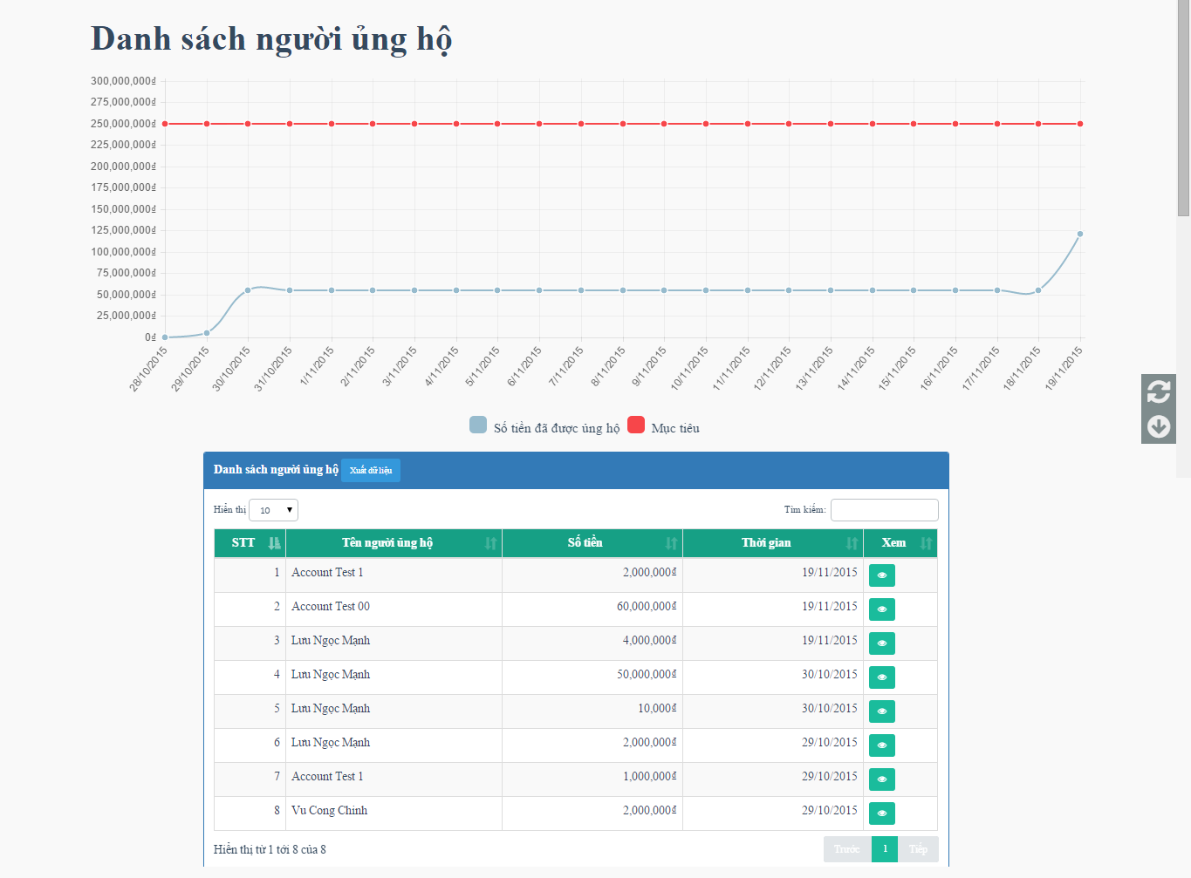

1. List backer screen

### Backed project

In this page help user manage project backed. To view project backed user do the steps below:

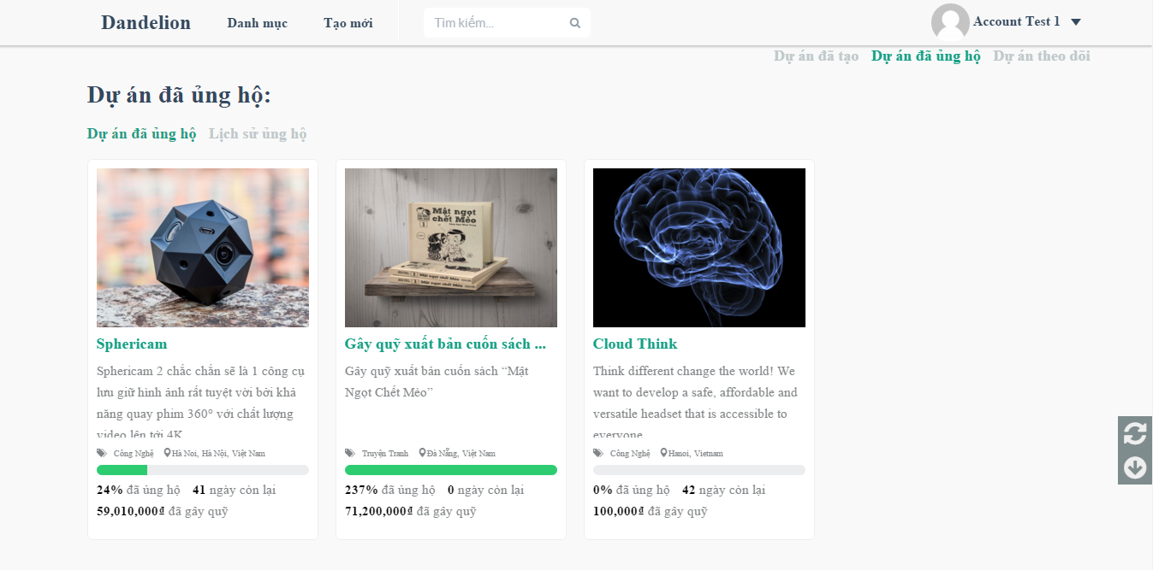

1. Backed project screen

Step 1: Click on avatar in header, then click on Backed Project “Dự án ủng hộ” button. System will go to backed project page.

Step 2: Click on “Lịch sử ủng hộ”

Step 3: Choose a project and click view details.

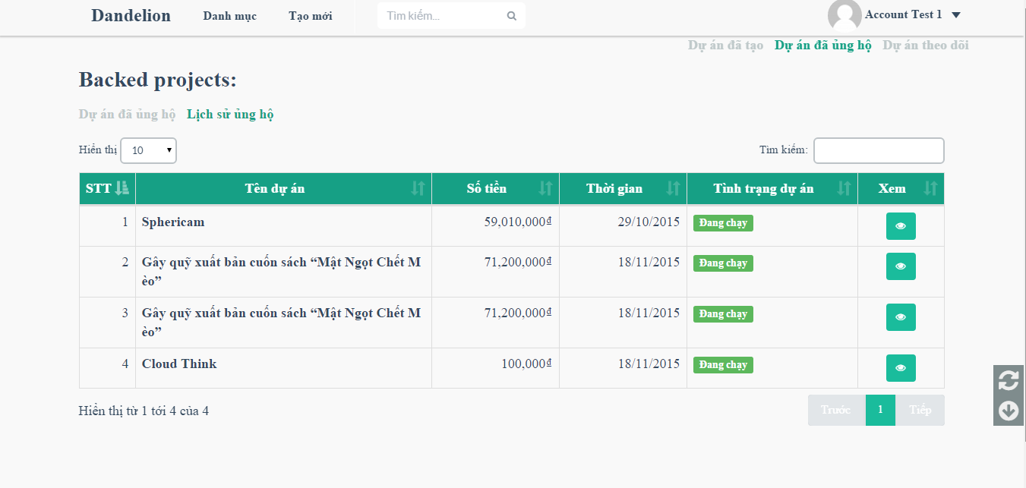

1. Backed project history screen

### Starred project

To view project reminded user do the steps below:

Step 1: Click on avatar in header, then click on Backed Project “Dự án theo dõi” button. System will go to backed project page.

Step 2: Click on “X” icon to cancel remind a project

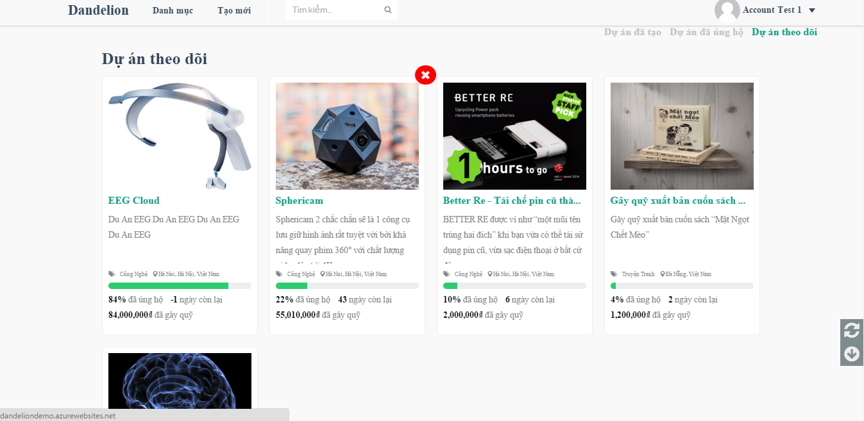

1. Starred project screen

## Account management

### Change password

To change password user do the steps below:

Step 1: Click on avatar in header, then click on “Tài khoản” button. System will go to account project page.

Step 2: Click on “Thay đổi mật khẩu” button

Step 3: Enter current pass, new pass, confirm pass.

Step 4: Click “Lưu thiết lập” button.

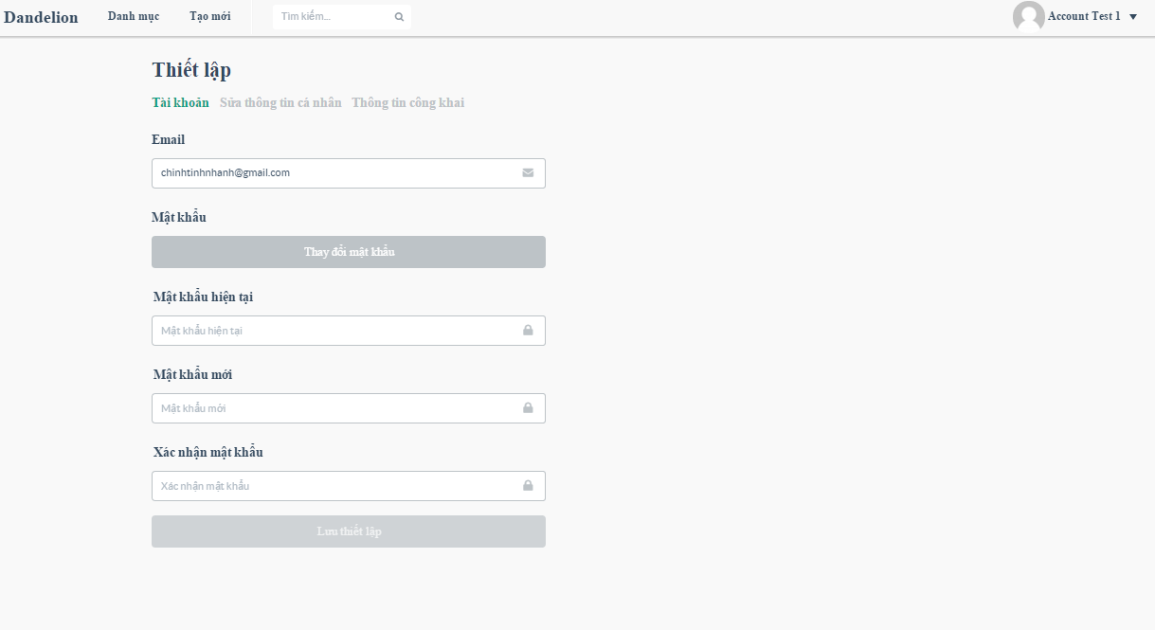

1. Account screen

### Edit profile

To change password user do the steps below:

Step 1: Click on avatar in header, then click on “Tài khoản” button. System will go to account project page.

Step 2: Click on “Sửa thông tin cá nhân” button

Step 3: Enter information.

Step 4: Click “Lưu thiết lập” button.

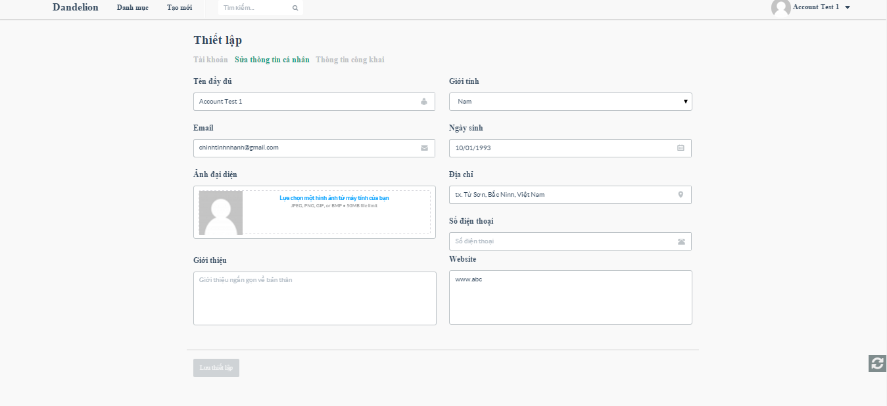

1. Edit profile screen

### Public profile

User can view public profile.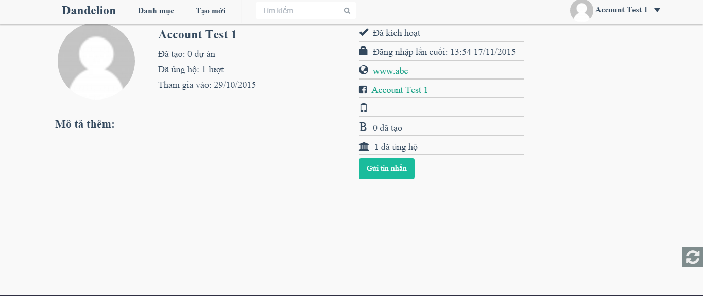

1. Public profile screen

## ADMIN

### Login

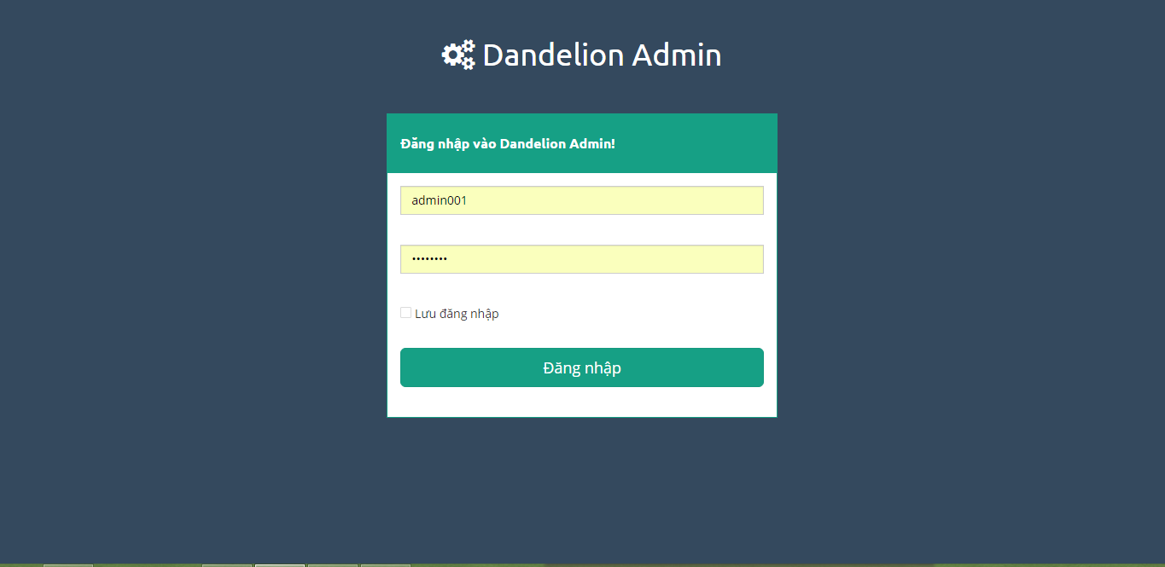

1. Login screen

To login admin account, the users do the steps below:

Step 1: Open browser and enter to the address bar: <http://dandelionvn.com/admin/login/>.

Step 2: User enter username and password

Step 3: Click on Login button

### Dashboard

At this page, Admin can view overview about project, user, guest.

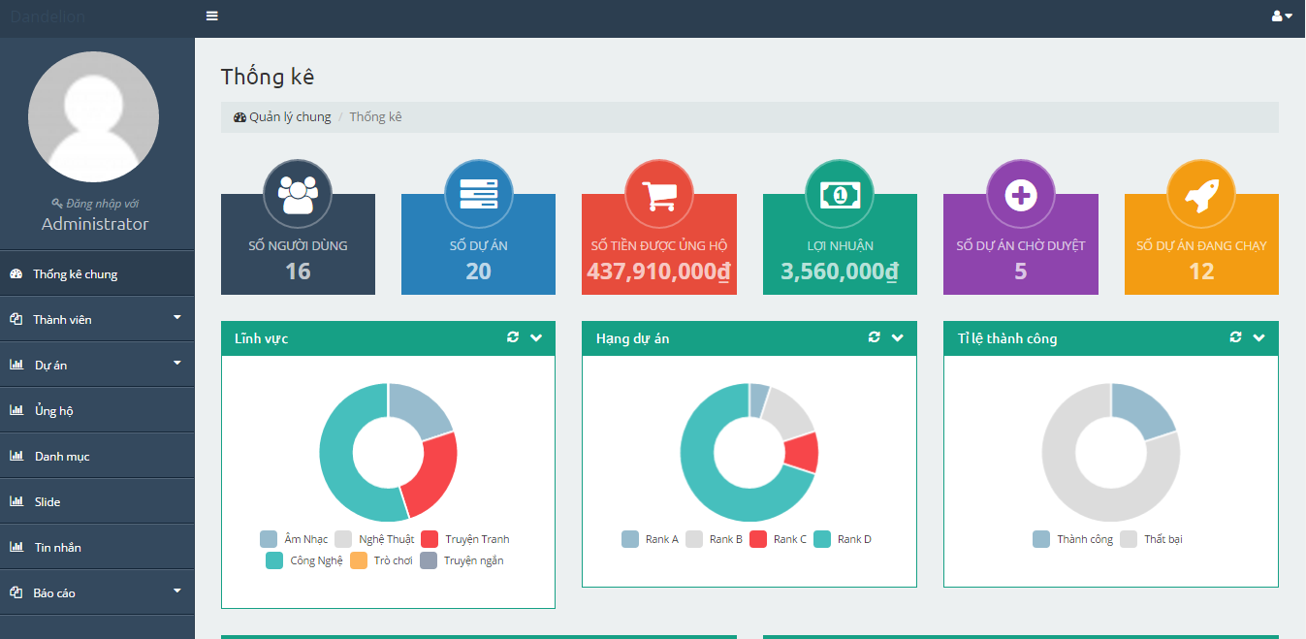

1. Dashboard 1

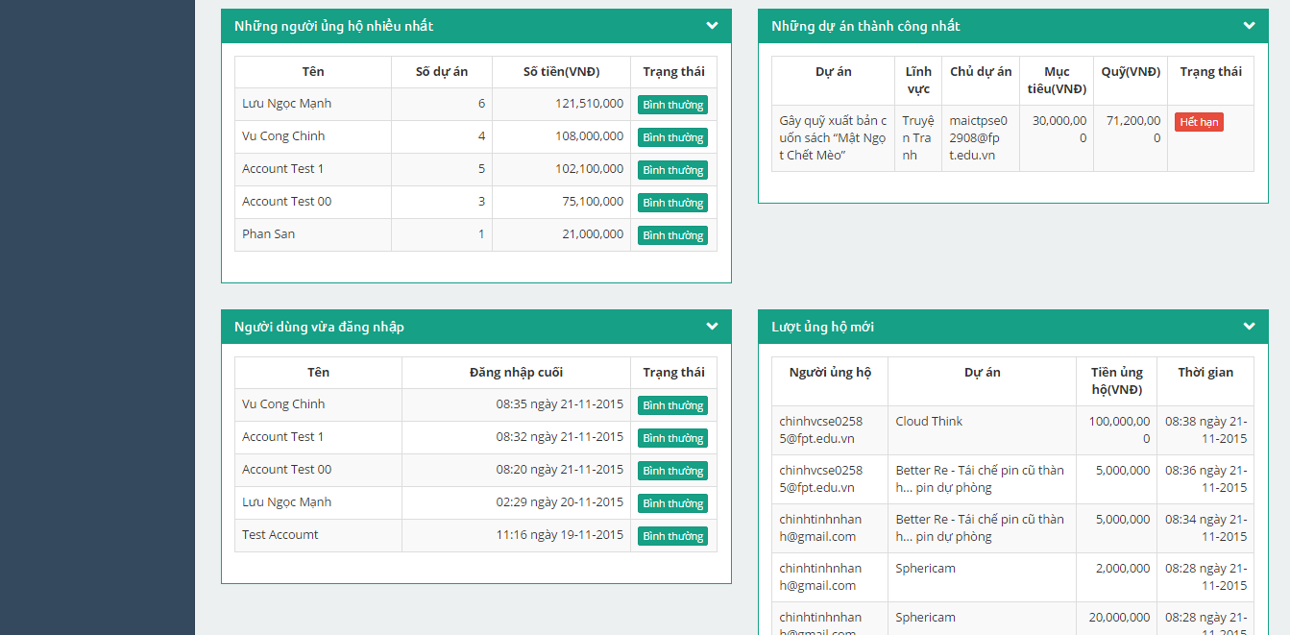

1. Dash board 2

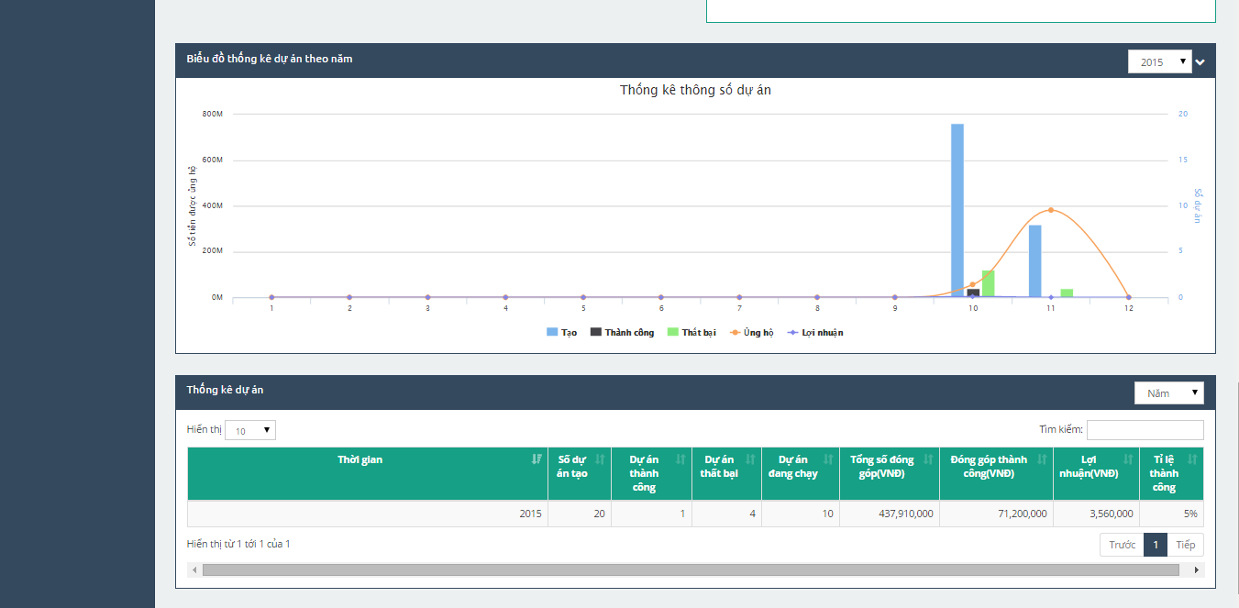

1. Dashboard 3

### Users

To lock/unlock a account. Admin do the step below:

Step 1: Go to Admin page, Click on “Danh sách thành viên”. System return list account.

Step 2: Choose account and click on lock/unlock icon button to lock/unlock account.

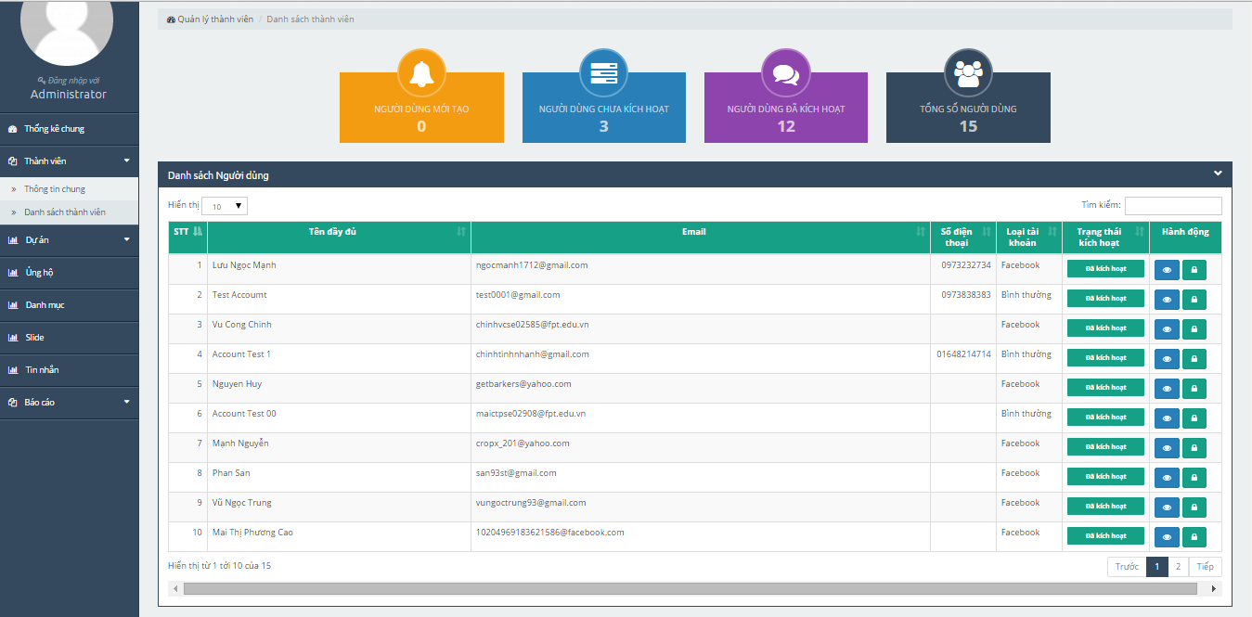

1. Users list screen

### Projects

To accept/reject project. Admin do the step below:

Step 1: Go to Admin page, Click on “Danh sách dự án”. System returns list project.

Step 2: Choose account and click view button. System go to project detail page.

Step 3: Click “Chấp nhận/Từ chối” button to accept/reject project.

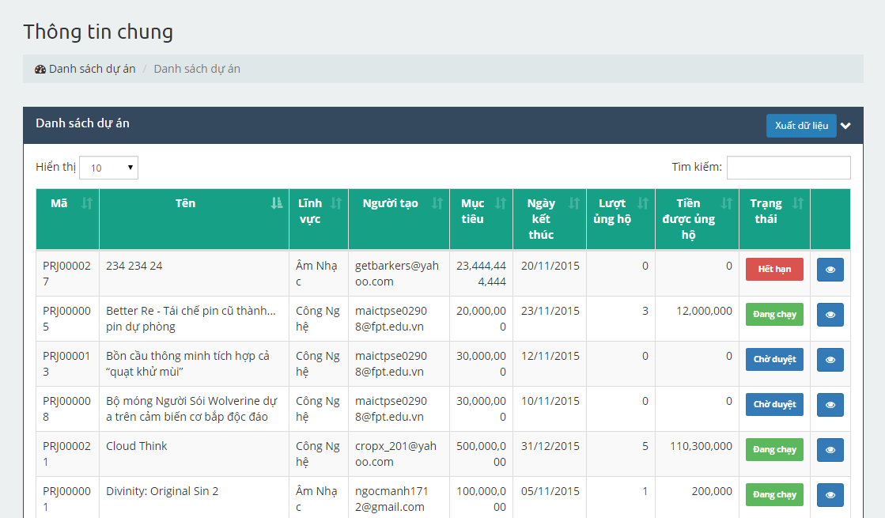

1. Projects list screen

### Backing

Admin can manage list banker.

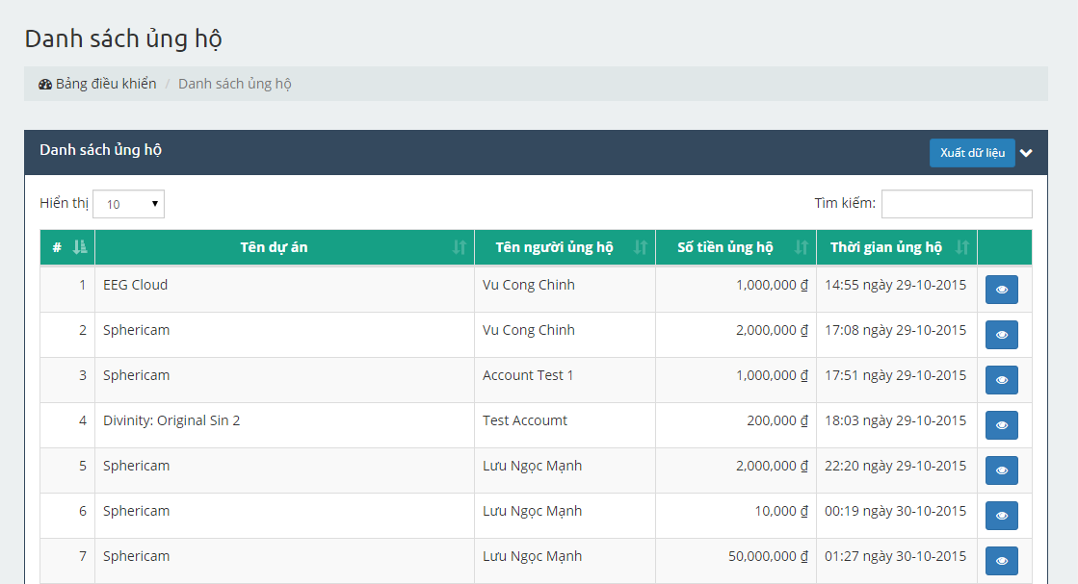

1. Backing list screen

### Category

Admin can manage categories. (Create new, edit, lock, unlock category)

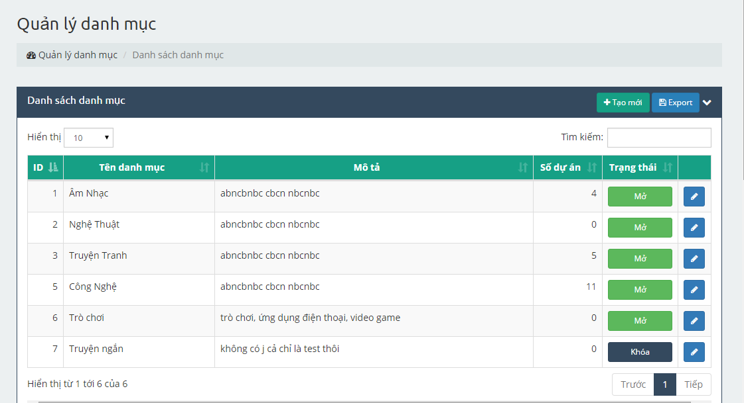

1. Category management screen

### Slider

Admin can manage sliders. (Create new, edit, lock, unlock slider)

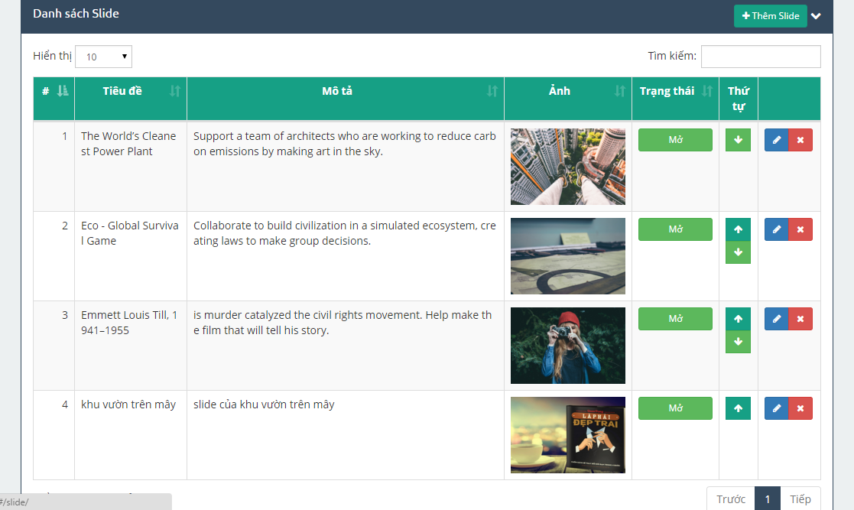

1. Slider management screen

### Message (same as message of user)

Admin can manage message. (Create sent, receive, delete message)

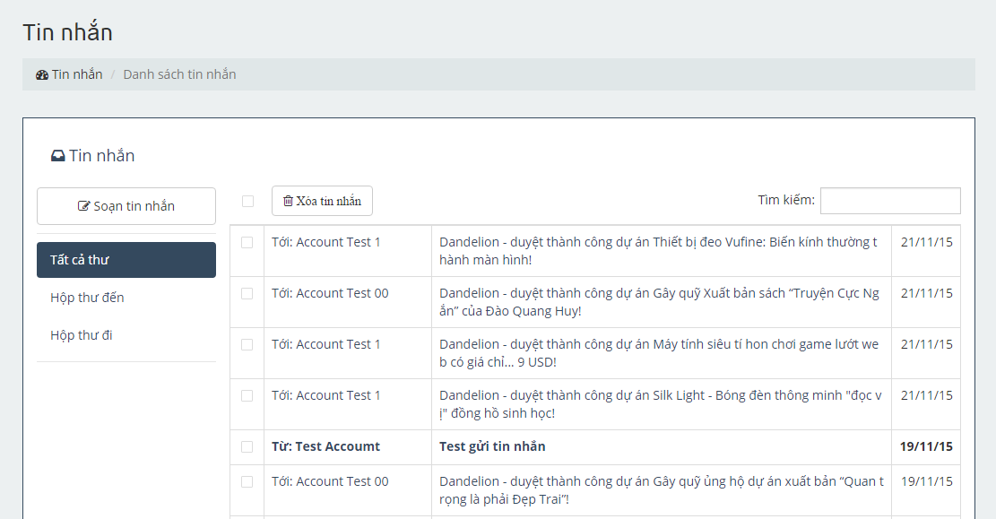

1. Message screen

### Report

#### Report user

Step 1: Click on Báo cáo người dung

Step 2: Choose user to report

Step 3: Click on Accept/Reject

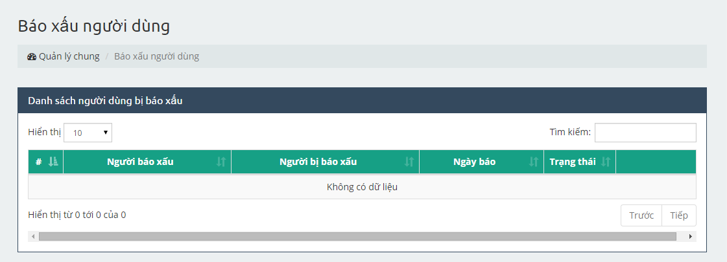

1. Report user management screen

#### Report project

Step 1: Click on Báo cáo dự án

Step 2: Choose project to report

Step 3: Click on Accept/Reject

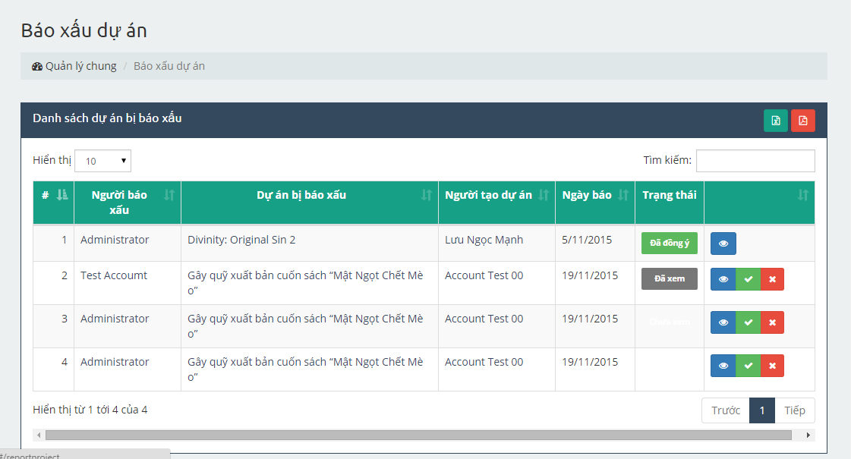

1. Report project management screen